**AFLORA**

Autonomous Farming Life-cycle Observation

with Real-time Analytics

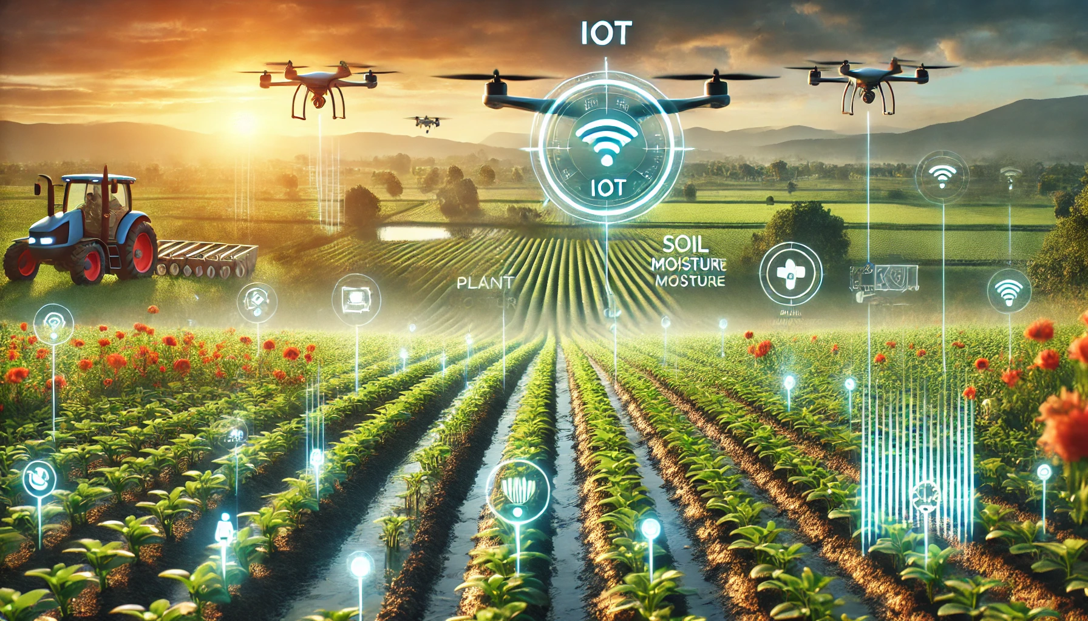



Department of Information Engineering, Computer Science and Mathematics   
  
University Of L’Aquila, Italy  
  
**Professor Davide Di Ruscio**   
  
**Software Engineering for Autonomous Systems**

| **Studente** | **Matricola** | **Email** |
| --- | --- | --- |
| Calogero Carlino | 302154 | calogero.carlino@student.univaq.it |
| Luca Francesco Macera | 302123 | lucafrancesco.macera@student.univaq.it |

**Table of contents**

1. Introduction 4

2. Goals 4

3. Managed Resources 5

4. Sensors and effectors 5

5. Adaptation goals 6

# Introduction

Our project will monitor data related on both environment and plants that span from weather data such as temperature, humidity, rainfall, solar radiation, light intensity, CO2 level and soil moisture; going over plant’s health data such as ph, concentration of mineral salts, chlorophyll content, leaf temperature, plant stress levels and pest infestations; and lastly to crop yield data such as plant height and canopy density.

The goal of the system is to automate crop management to better optimize the resources available like water consumption, energy consumption and increase the quality and the yield of the crops.

The system will follow an **MAPE-K LOOP** architecture and will use the data gathered by the sensors to store and analyze the current state of the crops in order to decide which actuator to activate when the levels detected go above the pre-established thresholds.

# Goals

The goals of the systems will be:

* Reliable IoT system for real-time monitoring of crops and fields.
  + Develop a robust loT system capable of tracking the temperature, humidity, and air quality
* Maintaining sensor data below the thresholds
  + The system will activate the correct actuators such as smart windows or irrigation hose to maintain the sensed data below the fixed thresholds for the sensors used.
* Smart alarm system to alert the farmers in case of plant hazards.
  + Integrate an alarm system that alarms the users when the registered levels go above the configured thresholds.
* Smart notification system to notify the farmers when an action was taken
  + Integrate a notification system that notifies the users when the registered levels go above the configured thresholds and an action was taken to correct these levels.
* User-friendly web-based dashboard accessible to the farmers
  + Create a dashboard that provides real-time updates on plant health and crop fields’ environmental-related condition

# Managed Resources

The managed resources of the system will be:

* Irrigation System
  + The system will use soil moisture data to determine the irrigation needs of the plant terrain. These will maximize irrigation efficiency by reducing water waste, while maintaining plant health and quality
* Ventilation System
  + In greenhouses, the system will sense high CO2 levels in the air, which are bad for the plant health, and replace it with fresh air from the outside
* Notification System
  + The system will notify the farmers when a particular action was taken, like for example, irrigating a particular field or opening a window in a greenhouse
* Alarm System
  + The system will use devices capable of alerting the farmers present in the area in case of high CO2, fine dust and temperature levels. This allows the personnel to act on quickly in order to resolve the problem that may arise.

# Sensors and effectors

* Effectors:
  + One actuator for each plant to pour water
  + One actuator for each greenhouse window to open/close them
* Sensors:
  + One humidity sensor per greenhouse that perceives if the greenhouse condition is normal/anormal
  + One CO2 level sensor per greenhouse that perceives if the CO2 level of the greenhouse is too high
  + One smoke detector sensor per greenhouse that perceives if there is a fire in the greenhouse
  + One fine dust sensor per greenhouse that perceives the level of fine dusts in the air
  + One temperature sensor per greenhouse that perceive if the temperature level is too high
  + One soil moisture sensor per plant that perceives if the plant needs irrigation

# Adaptation goals

| **GOALS** | **DESCRIPTION** | **EVALUATION METRIC** |
| --- | --- | --- |
| Maintain the humidity level (%RH) within the limits of harmful values | The humidity concentration must remain inside the optimal interval | 40 < %RH < 60 |
| Maintain the quality of CO2 below harmful levels | The concentration of CO2 must remain below the harmful threshold | Limit: CO2<10000 ppm  Lethal limit: CO2<50000 ppm |
| Maintain the quantity of fine dust matter (PM) between harmful levels | The concentration of fine dust must remain below the harmful threshold | Limit: PM < 15 μg/m3  Lethal limit: PM < 50 μg/m3 |
| Maintain the temperature level (°CT) of the greenhouse within the limits of harmful values | The temperature must remain inside the optimal interval | Daytime: 18 < °CT < 30  Nighttime: 13 < °CT < 21 |
| Notify the farmers through the notification when an action was taken | Farmers must be notified when an action was taken in order to preserve plant health | 40 < %RH < 60  CO2<50000 ppm  PM < 50 μg/m3  Daytime: 18 < °CT < 30  Nighttime: 13 < °CT < 21 |
| Alert the farmers through the alarm when the parameters exceed the lethal safety limits | It is important to alert the farmers for preserving plant health | 40 < %RH < 60  CO2<50000 ppm  PM < 50 μg/m3  Daytime: 18 < °CT < 30  Nighttime: 13 < °CT < 21 |